**SOP for Filling Personal Profile and Training data in HRMS platform..**

**Step 1:**

Please go the website of GSWS. https://gramawardsachivalayam.ap.gov.in/

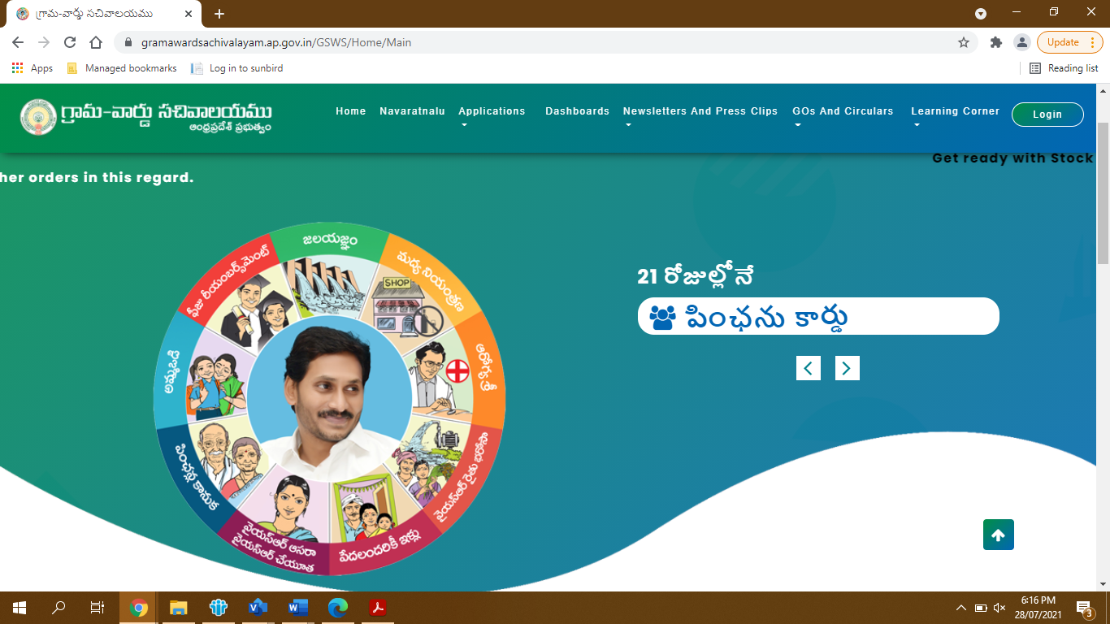

**Step 2:**

Click on the Applications tab on the website as shown below and click on the Human Resources Management option given in the drop down.

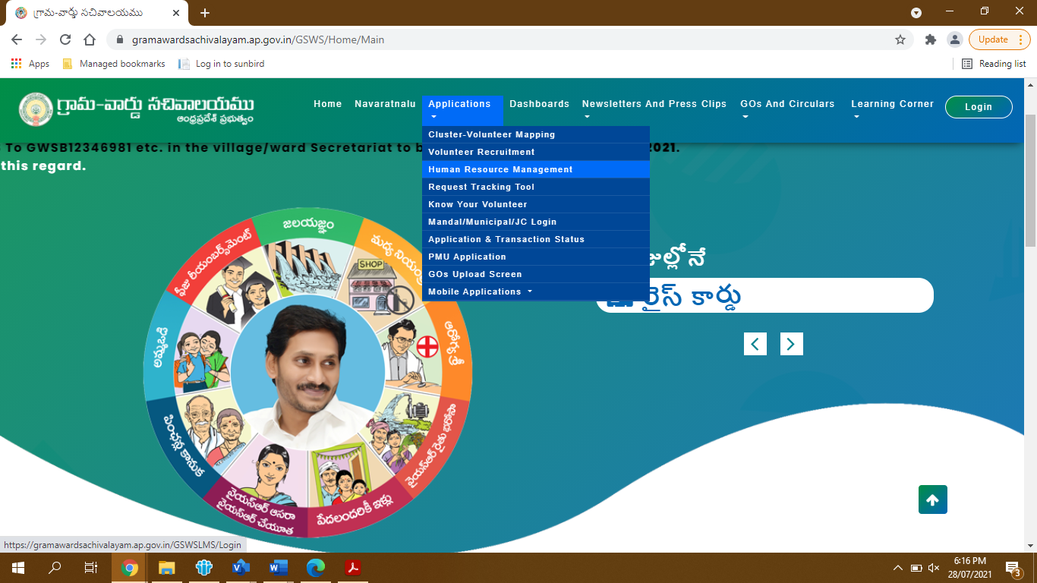

**Step 3:**

You will be redirected to another tab which would open the login page into HRMS or Leave Management portal (LMS).

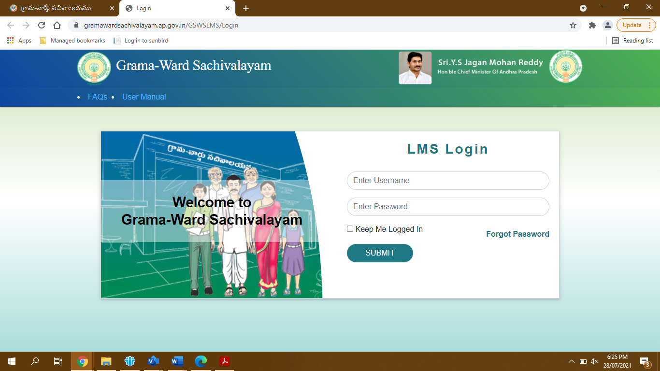

**Step 4:**

The first page as you login into HRMS, shows up as the screen below. It has the Profile tab as shown in the screen below. The Profile tab will show you the Personal Profile option, as seen in the drop down, below.

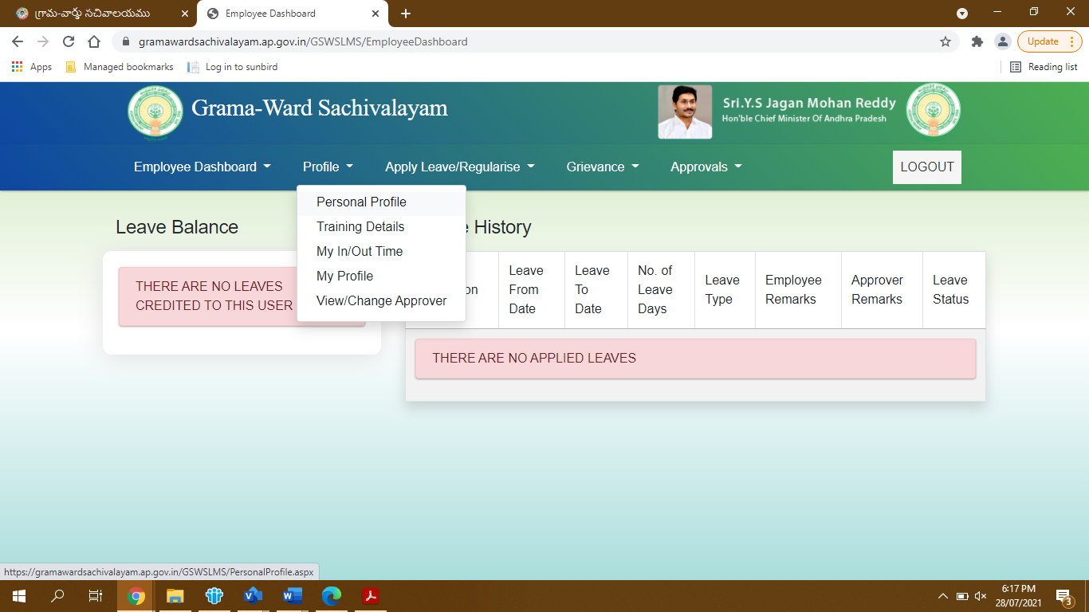

**Step 5:**

As you click on the Personal Profile option, the following screen comes up. It has 5 tabs as seen below- Basic Details, Religion and Caste Details, Address Details, Family Details, Education and Employment Details.

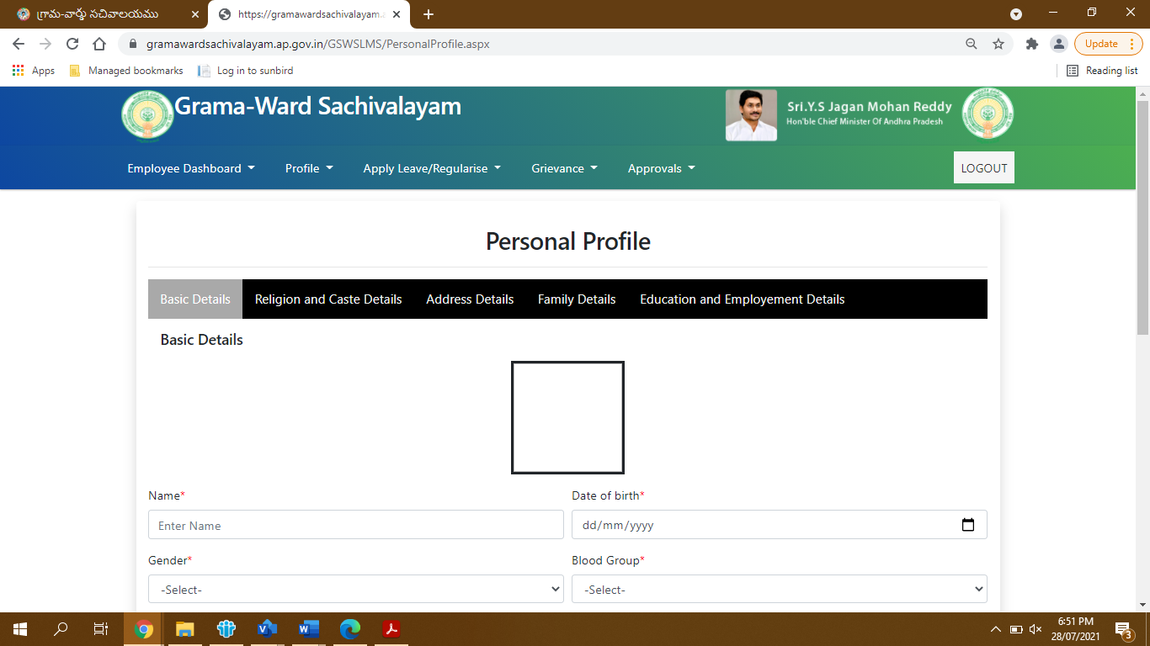

**Step 6:**

Filling up the details in each screen with your personal details as asked, would help to complete your personal profile. At end of each tab, the Next button is there, which would take you to next tab. However, you can also migrate between tabs in case of changes which you need to make in any.

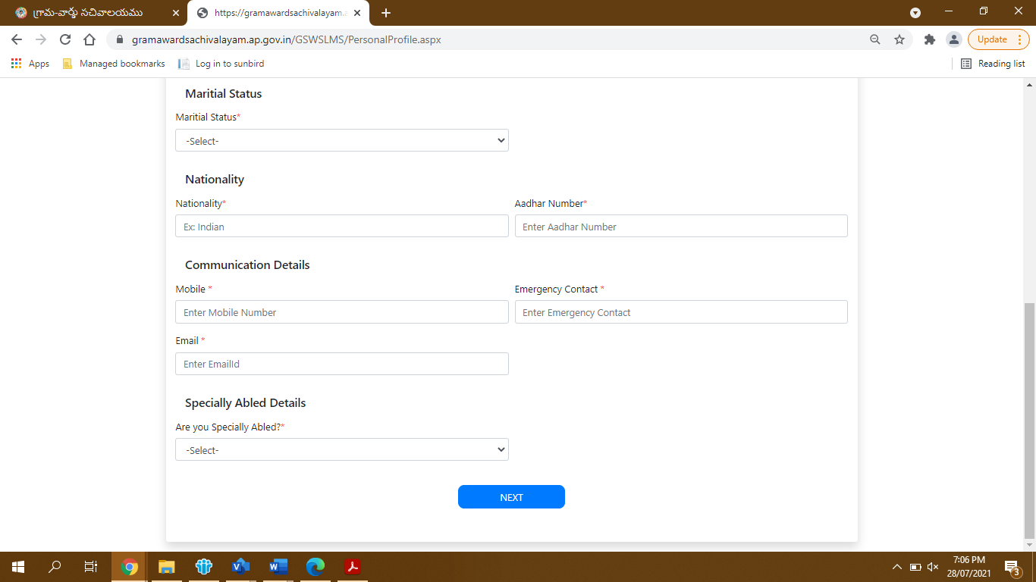

**Step 7:**

The Religion and Caste Details is the second tab as shown below. You can select the right option from the drop down in each.

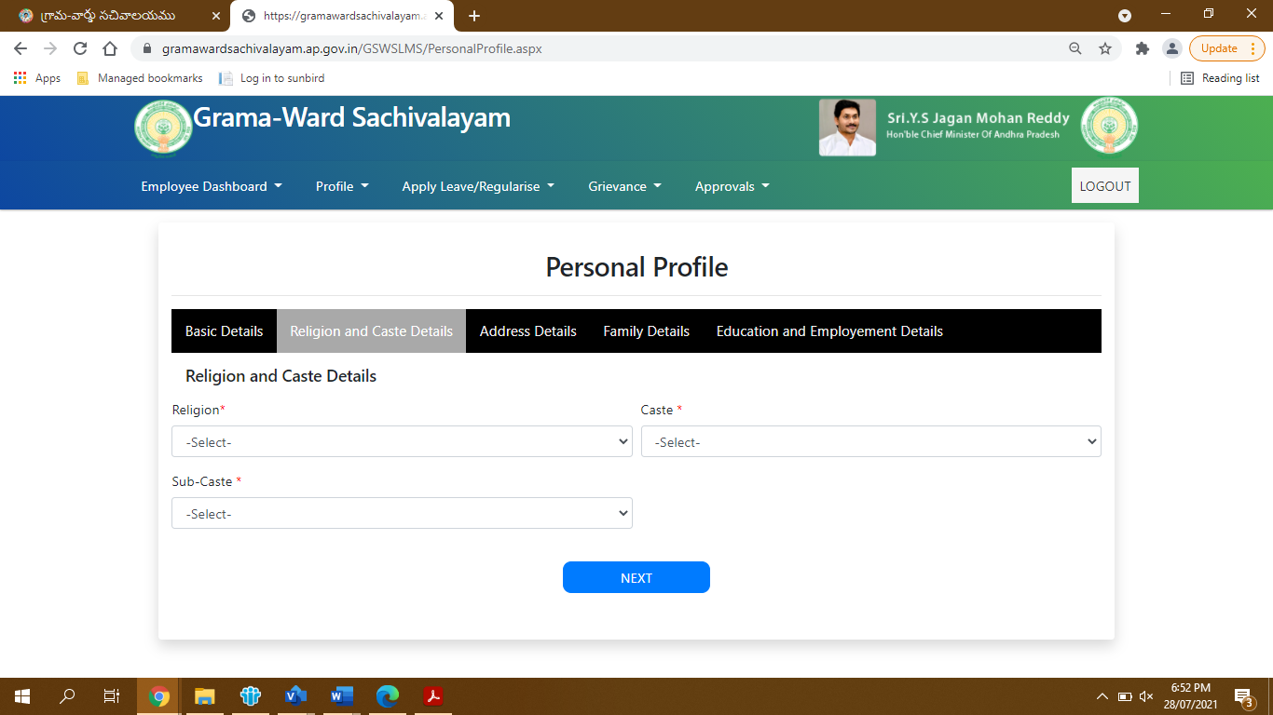

**Step 8:**

The Address Details has the Present, Permanent and Birth Address Details to be filled in.

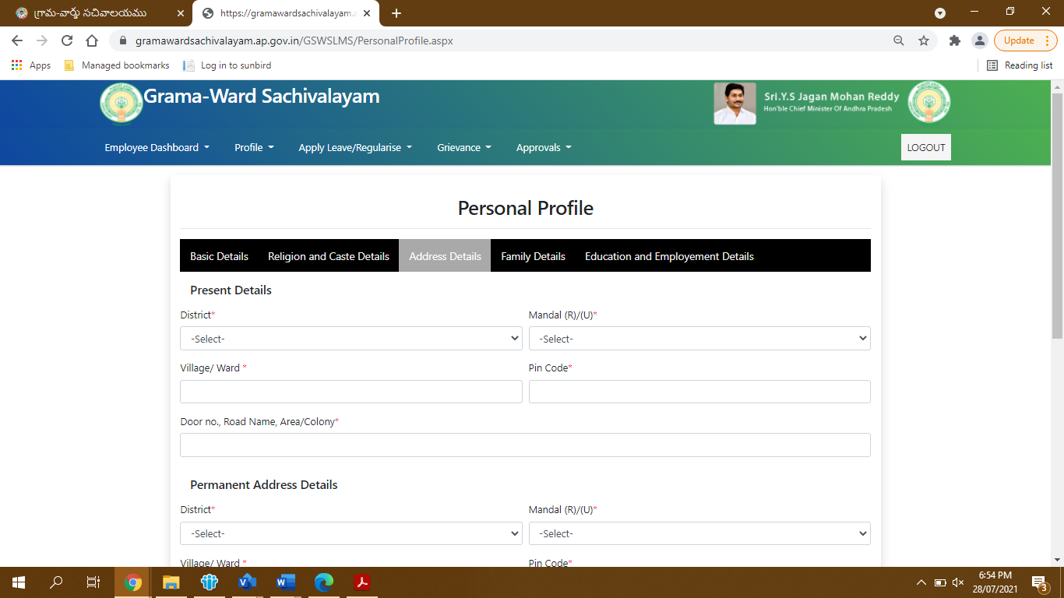

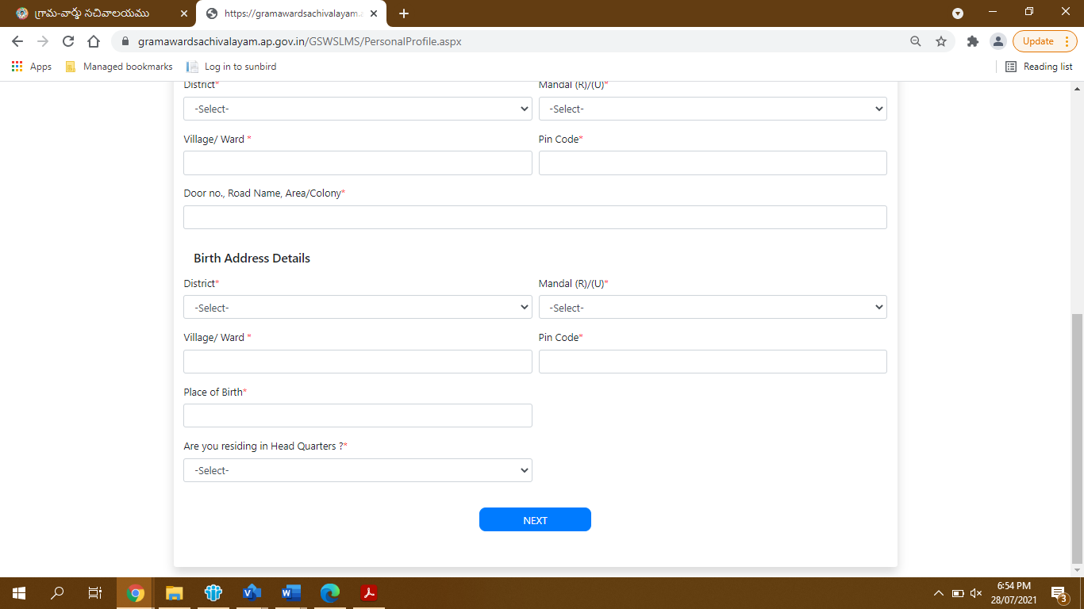

**Step 9:**

The Family Details is the fourth tab, where you can add family members one by one by clicking on the Add option shown in the screen below.

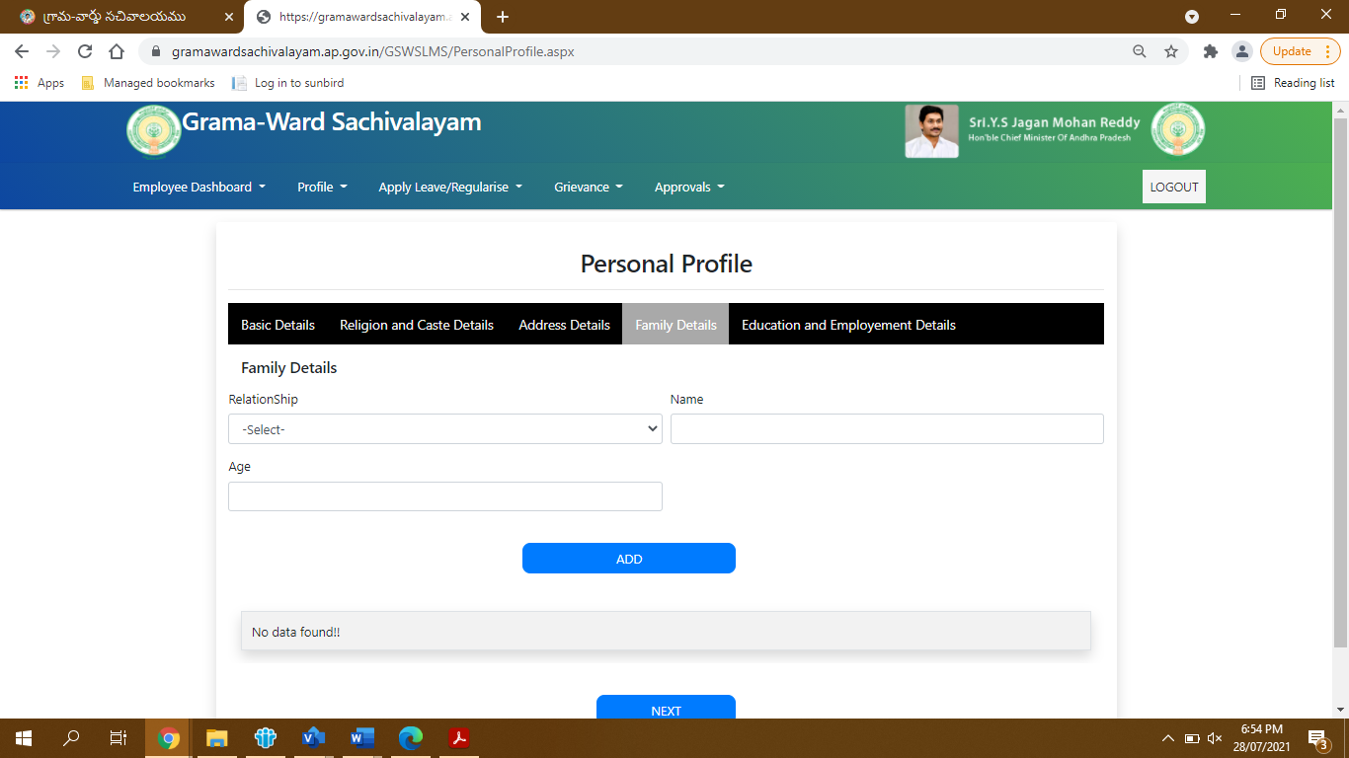

**Step 10:**

In the final tab you are required to fill in the Education and Employment Details.

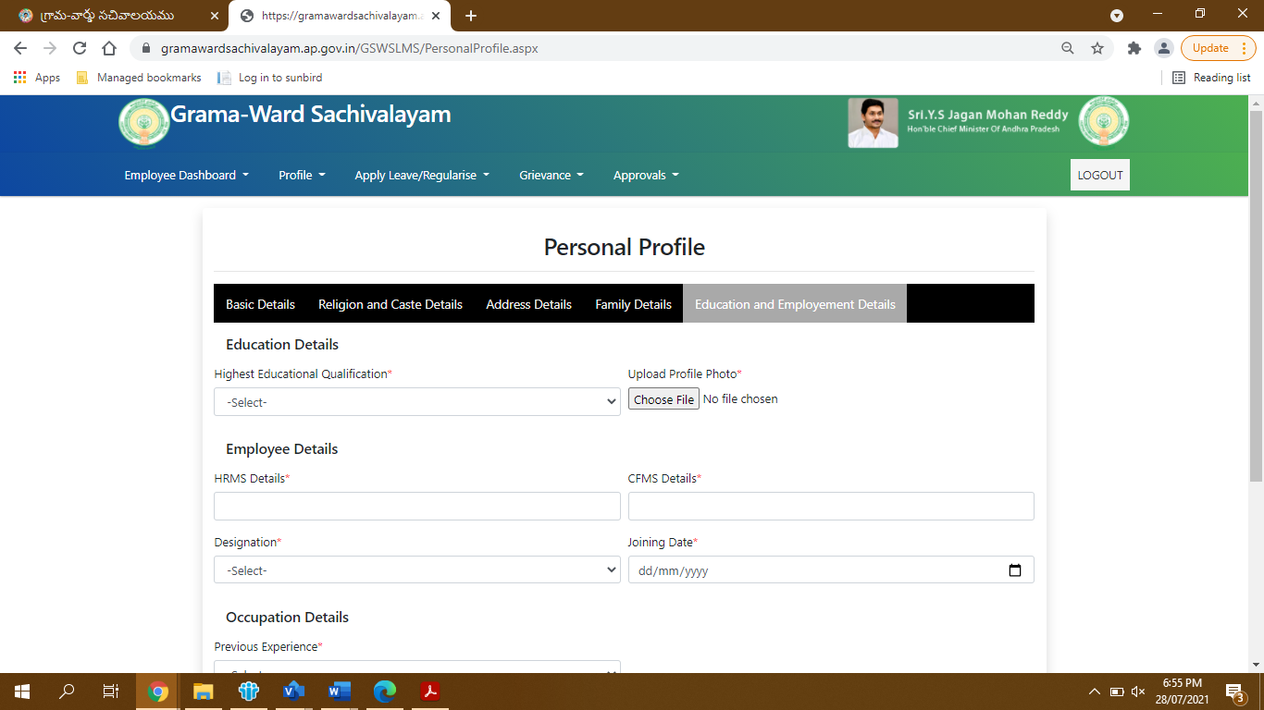

In the section of Department Test Details, you can add more than one test by clicking on the Add option shown below. You would need to upload result sheet in case of examination passed as shown in the option below.

Click on the Save option given below to save the details.

**Step 11:** Go to Home page in the HRMS module and click on Profile tab and choose training details in the profiele tab as shown in the screen below.



**Step 12:** the Training details screen will show as below… please fill the all trainings attended by the functionary and save the details

